

**Module Code: IS4S761**

**Module Title: Principles of Computing**

**Module Team: Gaylor Boobyer**

**Submitted By: Tania Rahman (30076078)**

**76/100**

**Peter Darwin’s Estate Agency**

**a) Table definition**

**-- Potential buyer table --**

CREATE TABLE potential_buyer(

buyer_no NUMBER GENERATED BY DEFAULT AS IDENTITY,

first_name VARCHAR2(20) NOT NULL,

last_name VARCHAR2(20) NOT NULL,

address VARCHAR2(20) NOT NULL,

area VARCHAR2(20) NOT NULL,

minimum_bedrooms_no NUMBER NOT NULL,

minimum_bathrooms_no NUMBER NOT NULL,

minimum_reception_rooms NUMBER NOT NULL,

garage VARCHAR2(20) NOT NULL,

maximum_price decimal(8, 2) NOT NULL,

PRIMARY KEY(buyer_no),

CONSTRAINT garage_preference CHECK(garage IN ('required', 'not required'))

);

Not good practice to use auto generated number for the Primary Key

Not good practice not to use a Constraint Name for the Primary Key

**-- Staff member table --**

CREATE TABLE staff_members(

staff_id VARCHAR(10),

first_name VARCHAR(20) NOT NULL,

last_name VARCHAR(20) NOT NULL,

staff_manager VARCHAR(10),

PRIMARY KEY(staff_id)

);

Not good practice not to use a Constraint Name for the Primary Key

**-- Seller table --**

CREATE TABLE seller(

seller_id VARCHAR2(10),

first_name VARCHAR2(20) NOT NULL,

last_name VARCHAR2(20) NOT NULL,

address VARCHAR2(20) NOT NULL,

contact NUMBER NOT NULL,

PRIMARY KEY (seller_id)

);

Not good practice not to use a Constraint Name for the Primary Key

**-- Sale property table --**

CREATE TABLE sale_property(

property_code VARCHAR2(20),

property_type VARCHAR2(20) NOT NULL,

address VARCHAR2(20) NOT NULL,

area VARCHAR2(20) NOT NULL,

no_of_bedrooms NUMBER NOT NULL,

no_of_bathrooms NUMBER NOT NULL,

no_of_reception_rooms NUMBER NOT NULL,

garage_available CHAR(1) NOT NULL,

sale_price DECIMAL(8, 2) NOT NULL,

property_state VARCHAR2 (10) NOT NULL,

placement_date DATE NOT NULL,

seller_id VARCHAR2(10) NOT NULL,

PRIMARY KEY(property_code),

CONSTRAINT property_type CHECK(property_type in ('Detached', 'Semi-detached', 'Terrace', 'Link')),

CONSTRAINT garage_availability CHECK(garage_available in ('Y','N')),

CONSTRAINT property_state CHECK(property_state IN ('Unsold','Sold')),

FOREIGN KEY(seller_id) REFERENCES seller (seller_id)

);

Not good practice not to use a Constraint Name for the Primary Key

**-- Viewing appointment table --**

CREATE TABLE viewing_appointment(

appointment_id VARCHAR2(5),

property_code VARCHAR2(20) NOT NULL,

buyer_no NUMBER NOT NULL,

staff_id VARCHAR2(10) NOT NULL,

PRIMARY KEY(appointment_id),

Appointment is a Link Table (Entity) and so the Primary Key must be PropertyCode, StaffMemberNo,BuyerNo, Date - minus 7

FOREIGN KEY (property_code) REFERENCES sale_property(property_code),

FOREIGN KEY (buyer_no) REFERENCES potential_buyer(buyer_no),

FOREIGN KEY (staff_id) REFERENCES staff_members(staff_id)

);

Not good practice not to use a Constraint Name for the Primary Key

23/30 +2 for Checks

**b) Table population**

**--populate potential buyer table --**

INSERT INTO potential_buyer(first_name,last_name,address,area,minimum_bedrooms_no,minimum_bathrooms_no,minimum_reception_rooms, garage,maximum_price)

VALUES('John', 'Mike', '22 4th Street', 'Aberdeen',1,1,1,'not required',300);

INSERT INTO potential_buyer(first_name,last_name,address,area,minimum_bedrooms_no,minimum_bathrooms_no,minimum_reception_rooms, garage,maximum_price)

VALUES('Kasper', 'Miles', '11th Street', 'Armagh',4,1,1,'required',600);

INSERT INTO potential_buyer(first_name,last_name,address,area,minimum_bedrooms_no,minimum_bathrooms_no,minimum_reception_rooms, garage,maximum_price)

VALUES('Kate', 'Micasa', 'North Rd.', 'Bangor',3,2,2,'required',800);

INSERT INTO potential_buyer(first_name,last_name,address,area,minimum_bedrooms_no,minimum_bathrooms_no,minimum_reception_rooms, garage,maximum_price)

VALUES('Jack', 'Daniels', 'Abbey Church', 'Bath',5,3,2,'not required',1500);

INSERT INTO potential_buyer(first_name,last_name,address,area,minimum_bedrooms_no,minimum_bathrooms_no,minimum_reception_rooms, garage,maximum_price)

VALUES('Shawn', 'Niles', 'Belfast', 'Belfast',4,2,1,'not required',2500);

INSERT INTO potential_buyer(first_name,last_name,address,area,minimum_bedrooms_no,minimum_bathrooms_no,minimum_reception_rooms, garage,maximum_price)

VALUES('Martha', 'Mary', '1889 Midlands', 'Birmingham',4,4,1,'required',1500);

INSERT INTO potential_buyer(first_name,last_name,address,area,minimum_bedrooms_no,minimum_bathrooms_no,minimum_reception_rooms, garage,maximum_price)

VALUES('Daniel', 'Rush', 'North Street', 'Bradford',5,4,2,'required',3500);

INSERT INTO potential_buyer(first_name,last_name,address,area,minimum_bedrooms_no,minimum_bathrooms_no,minimum_reception_rooms, garage,maximum_price)

VALUES('Marcus', 'Garvey', 'Wall Rd.', 'Brighton',4,4,4,'required',3500);

INSERT INTO potential_buyer(first_name,last_name,address,area,minimum_bedrooms_no,minimum_bathrooms_no,minimum_reception_rooms, garage,maximum_price)

VALUES('Chris', 'Newton', '10 Bris', 'Bristol',3,2,1,'not required',1700);

**-- Staff member table population --**

INSERT ALL

INTO staff_members(staff_id,first_name,last_name,staff_manager) VALUES('S001','Shree', 'Kaptcha',null)

INTO staff_members(staff_id,first_name,last_name,staff_manager) VALUES('S002','John', 'James','S001')

INTO staff_members(staff_id,first_name,last_name,staff_manager) VALUES('S003','Anthony', 'Griezzy',null)

INTO staff_members(staff_id,first_name,last_name,staff_manager) VALUES('S004','David', 'Gea',null)

INTO staff_members(staff_id,first_name,last_name,staff_manager) VALUES('S005','Paulo', 'De Paul','S001')

INTO staff_members(staff_id,first_name,last_name,staff_manager) VALUES('S006','Harry', 'Pay',null)

INTO staff_members(staff_id,first_name,last_name,staff_manager) VALUES('S007','Martin', 'John','S001')

INTO staff_members(staff_id,first_name,last_name,staff_manager) VALUES('S008','Shree', 'Kaptcha',null)

SELECT 1 FROM dual;

**--seller table population --**

INSERT ALL

INTO seller(seller_id,first_name,last_name,address,contact) VALUES ('SE01','Peter','Paul','Rhodes 01',1111111111)

INTO seller(seller_id,first_name,last_name,address,contact) VALUES ('SE02','Sir','Kanlee','NewB',1100011111)

INTO seller(seller_id,first_name,last_name,address,contact) VALUES ('SE03','John','Junior','Lower Valley',1111117681)

INTO seller(seller_id,first_name,last_name,address,contact) VALUES ('SE04','Henry','Thierry','Upper 1',1111111546)

INTO seller(seller_id,first_name,last_name,address,contact) VALUES ('SE05','Pat','Mckinsey','DownTown',9001111111)

SELECT 1 FROM dual;

**-- sale_property population --**

INSERT ALL

INTO sale_property(property_code,property_type,address,area,no_of_bedrooms,no_of_bathrooms,no_of_reception_rooms,garage_available,sale_price,property_state,placement_date, seller_id)

VALUES ('PS01','Detached','Rhodes 1','London',6,4,3,'Y',700,'Unsold',TO_DATE('2022-07-02', 'YYYY-MM-DD'), 'SE01')

INTO sale_property(property_code,property_type,address,area,no_of_bedrooms,no_of_bathrooms,no_of_reception_rooms,garage_available,sale_price,property_state,placement_date, seller_id)

VALUES ('PS02','Semi-detached','Link Rd.','Bristol',1,1,1,'N',200,'Sold',TO_DATE('2022-01-02', 'YYYY-MM-DD'), 'SE02')

INTO sale_property(property_code,property_type,address,area,no_of_bedrooms,no_of_bathrooms,no_of_reception_rooms,garage_available,sale_price,property_state,placement_date, seller_id)

VALUES ('PS03','Terrace','Main Rd','Canterbury',2,2,1,'Y',800,'Unsold',TO_DATE('2022-02-02', 'YYYY-MM-DD'), 'SE03')

INTO sale_property(property_code,property_type,address,area,no_of_bedrooms,no_of_bathrooms,no_of_reception_rooms,garage_available,sale_price,property_state,placement_date,seller_id)

VALUES ('PS04','Link','Air Street','Derby',2,1,0,'Y',350,'Unsold',TO_DATE('2022-08-02', 'YYYY-MM-DD'), 'SE04')

INTO sale_property(property_code,property_type,address,area,no_of_bedrooms,no_of_bathrooms,no_of_reception_rooms,garage_available,sale_price,property_state,placement_date,seller_id)

VALUES ('PS05','Terrace','One Way','Leeds',4,2,1,'Y',1000,'Unsold',TO_DATE('2022-11-02', 'YYYY-MM-DD'), 'SE05')

INTO sale_property(property_code,property_type,address,area,no_of_bedrooms,no_of_bathrooms,no_of_reception_rooms,garage_available,sale_price,property_state,placement_date,seller_id)

VALUES ('PS06','Detached','London St.','London',8,4,3,'Y',3500,'Unsold',TO_DATE('2022-10-02', 'YYYY-MM-DD'), 'SE01')

INTO sale_property(property_code,property_type,address,area,no_of_bedrooms,no_of_bathrooms,no_of_reception_rooms,garage_available,sale_price,property_state,placement_date,seller_id)

VALUES ('PS07','Detached','HallWay','Bristol',3,1,1,'Y',1500,'Sold',TO_DATE('2022-07-02', 'YYYY-MM-DD'), 'SE04')

INTO sale_property(property_code,property_type,address,area,no_of_bedrooms,no_of_bathrooms,no_of_reception_rooms,garage_available,sale_price,property_state,placement_date,seller_id)

VALUES ('PS08','Semi-detached','Halal','Canterbury',2,2,1,'Y',1200,'Unsold',TO_DATE('2022-07-01', 'YYYY-MM-DD'), 'SE02')

INTO sale_property(property_code,property_type,address,area,no_of_bedrooms,no_of_bathrooms,no_of_reception_rooms,garage_available,sale_price,property_state,placement_date,seller_id)

VALUES ('PS09','Link','Rowan','Leeds',2,1,0,'N',400,'Sold',TO_DATE('2022-05-02', 'YYYY-MM-DD'), 'SE03')

INTO sale_property(property_code,property_type,address,area,no_of_bedrooms,no_of_bathrooms,no_of_reception_rooms,garage_available,sale_price,property_state,placement_date,seller_id)

VALUES ('PS10','Link','OneWay','Derby',4,4,1,'Y',2000,'Unsold',TO_DATE('2022-07-10', 'YYYY-MM-DD'), 'SE01')

INTO sale_property(property_code,property_type,address,area,no_of_bedrooms,no_of_bathrooms,no_of_reception_rooms,garage_available,sale_price,property_state,placement_date,seller_id)

VALUES ('PS11','Terrace','Two Lane','Bristol',1,1,0,'N',190,'Unsold',TO_DATE('2022-06-02', 'YYYY-MM-DD'), 'SE04')

INTO sale_property(property_code,property_type,address,area,no_of_bedrooms,no_of_bathrooms,no_of_reception_rooms,garage_available,sale_price,property_state,placement_date,seller_id)

VALUES ('PS12','Semi-detached','Rhodes 1','London',4,4,1,'Y',1600,'Sold',TO_DATE('2022-04-02', 'YYYY-MM-DD'), 'SE02')

INTO sale_property(property_code,property_type,address,area,no_of_bedrooms,no_of_bathrooms,no_of_reception_rooms,garage_available,sale_price,property_state,placement_date,seller_id)

VALUES ('PS13','Terrace','Rhodes 4','Leeds',3,3,0,'Y',500,'Unsold',TO_DATE('2022-07-02', 'YYYY-MM-DD'), 'SE05')

INTO sale_property(property_code,property_type,address,area,no_of_bedrooms,no_of_bathrooms,no_of_reception_rooms,garage_available,sale_price,property_state,placement_date,seller_id)

VALUES ('PS14','Link','Miss Rd.','Canterbury',5,2,1,'N',2100,'Sold',TO_DATE('2022-09-02', 'YYYY-MM-DD'), 'SE01')

INTO sale_property(property_code,property_type,address,area,no_of_bedrooms,no_of_bathrooms,no_of_reception_rooms,garage_available,sale_price,property_state,placement_date,seller_id)

VALUES ('PS15','Link','Queen St.','Bristol',4,2,2,'Y',2500,'Sold',TO_DATE('2022-09-10', 'YYYY-MM-DD'), 'SE03')

INTO sale_property(property_code,property_type,address,area,no_of_bedrooms,no_of_bathrooms,no_of_reception_rooms,garage_available,sale_price,property_state,placement_date,seller_id)

VALUES ('PS16','Detached','Prince Rd.','London',6,4,3,'Y',800,'Unsold',TO_DATE('2022-07-03', 'YYYY-MM-DD'), 'SE02')

INTO sale_property(property_code,property_type,address,area,no_of_bedrooms,no_of_bathrooms,no_of_reception_rooms,garage_available,sale_price,property_state,placement_date,seller_id)

VALUES ('PS17','Terrace','Queen 2nd Rd.','Bristol',5,3,1,'Y',750,'Unsold',TO_DATE('2022-08-08', 'YYYY-MM-DD'), 'SE04')

INTO sale_property(property_code,property_type,address,area,no_of_bedrooms,no_of_bathrooms,no_of_reception_rooms,garage_available,sale_price,property_state,placement_date,seller_id)

VALUES ('PS18','Detached','New Street','Derby',3,3,2,'Y',300,'Unsold',TO_DATE('2022-02-01', 'YYYY-MM-DD'), 'SE05')

INTO sale_property(property_code,property_type,address,area,no_of_bedrooms,no_of_bathrooms,no_of_reception_rooms,garage_available,sale_price,property_state,placement_date,seller_id)

VALUES ('PS19','Semi-detached','North Rd.','Canterbury',4,2,2,'Y',1350,'Unsold',TO_DATE('2022-10-10', 'YYYY-MM-DD'), 'SE03')

SELECT 1 FROM dual;

**-- viewing_appointment table population --**

INSERT ALL

INTO viewing_appointment(appointment_id,property_code,buyer_no,staff_id,viewing_date) VALUES('AP01','PS18',61,'S001',TO_DATE('2022-12-01', 'YYYY-MM-DD'))

INTO viewing_appointment(appointment_id,property_code,buyer_no,staff_id,viewing_date) VALUES('AP02','PS10',69,'S004',TO_DATE('2022-12-02', 'YYYY-MM-DD'))

INTO viewing_appointment(appointment_id,property_code,buyer_no,staff_id,viewing_date) VALUES('AP03','PS05',65,'S003',TO_DATE('2022-12-03', 'YYYY-MM-DD'))

SELECT 1 FROM dual;

5/5

**c) (1) List of properties in particular area**

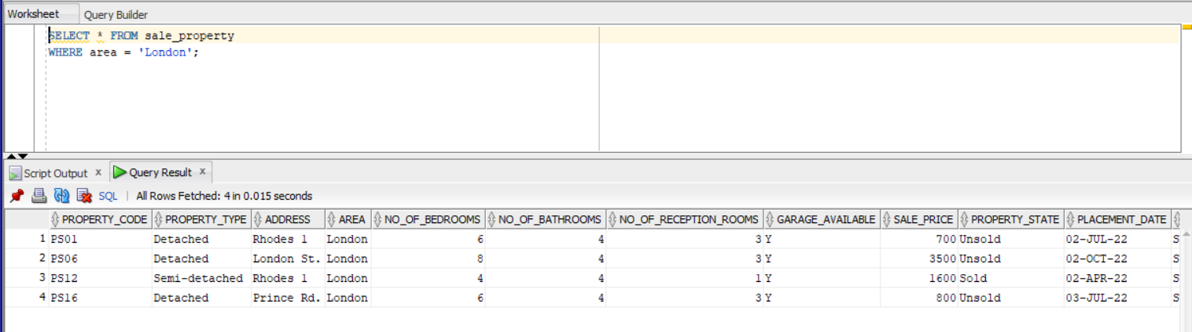

**3/3**

**(2) All Semi-detached properties that have been sold**

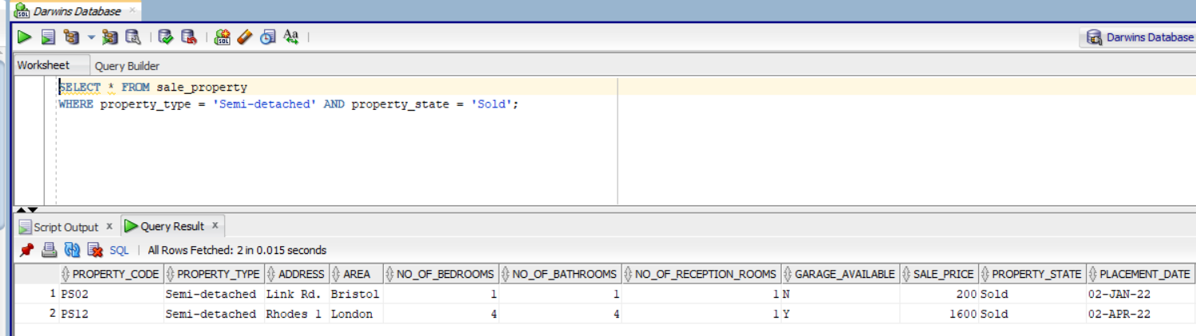

**4/4**

**Number of properties sold for each type**

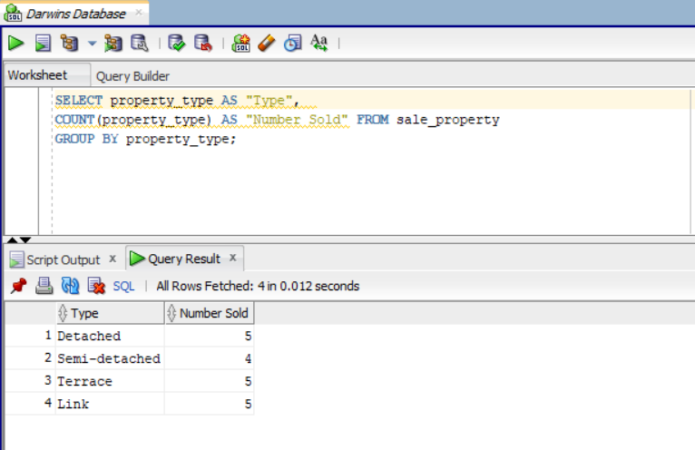

4/6

Where property is unsold (not sold) minus 2

(**4) Most expensive and least expensive properties**

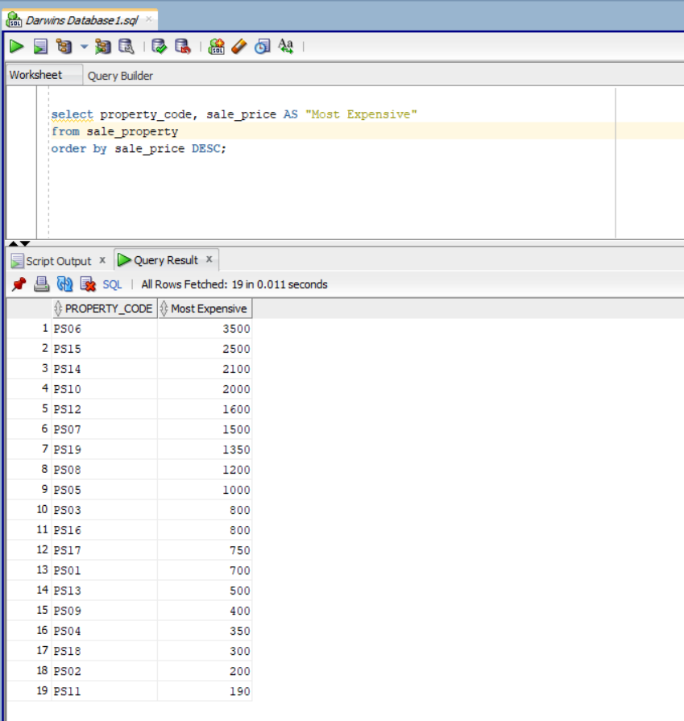

**1/6**

**(5) Produce a list of properties that satisfy the following requirements:**

***At least 3 bedrooms, at least 1 bathroom, has a garage***

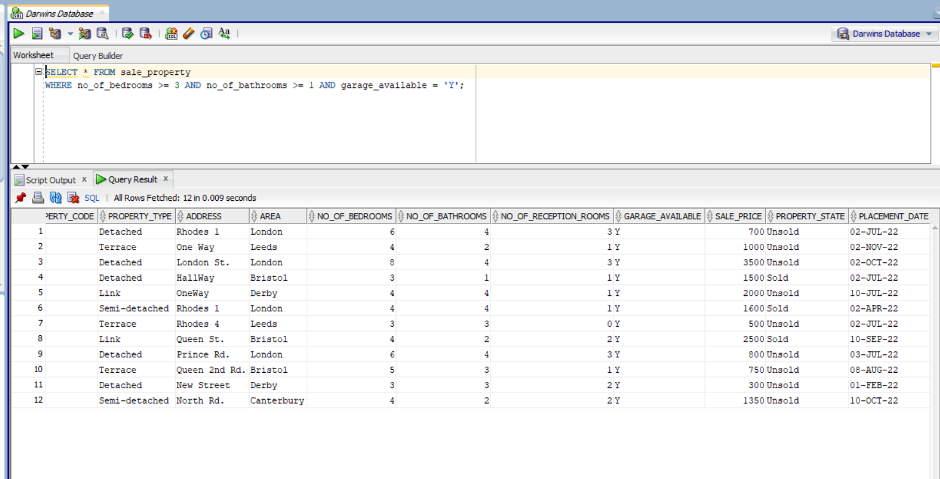

**5/5**

**(6) List of the properties put on market in January and February of 2022**

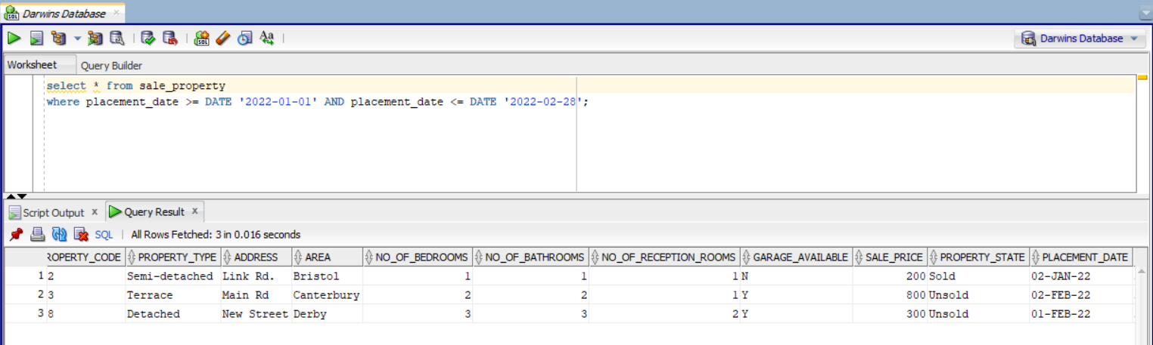

**6/6**

**(7) Most expensive and least expensive property type**

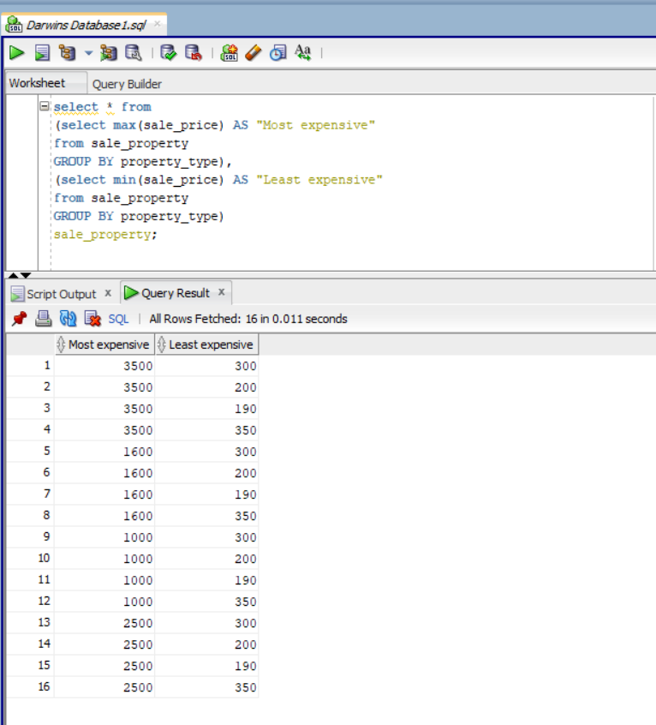

6/6

**(8) Produce a list of properties where viewing appointments will be supervised by a particular member of staff**

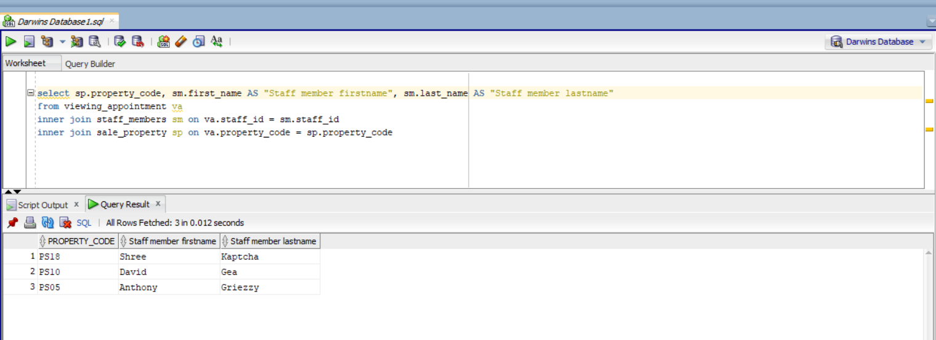

Staff name? 6/8

**(9) Produce a list of viewing appointments to include the potential buyer’s name, the seller’s name, the property’s address, the staff member’s name and the date and time of the appointment**

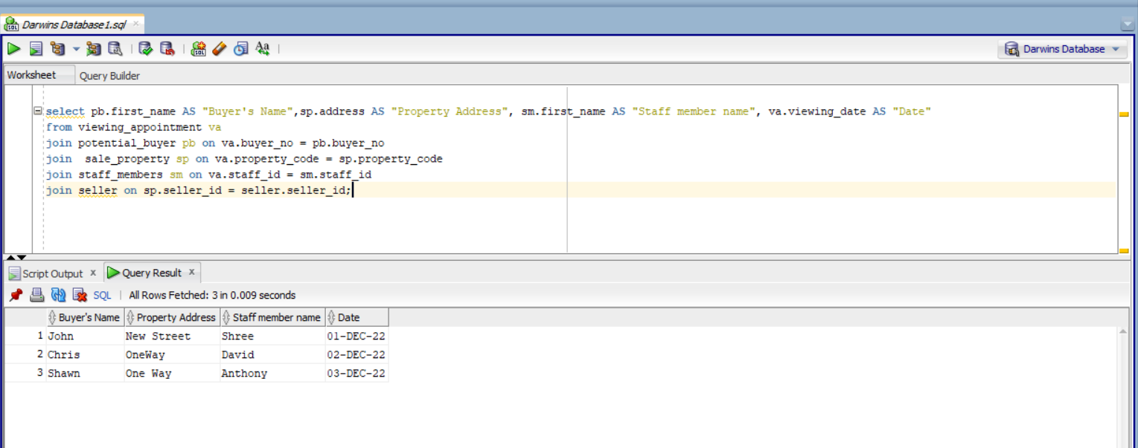

11/11